人生不如意之事十之八九，合并分支往往也不是一帆风顺的。

准备新的feature1分支，继续我们的新分支开发：

$ git checkout -b feature1

Switched to a new branch 'feature1'

修改readme.txt最后一行，改为：

Creating a **new** branch is quick **AND** simple.

在feature1分支上提交：

$ git add readme.txt

$ git **commit** -m "AND simple"

[feature1 14096d0] **AND** simple

1 file changed, 1 insertion(+), 1 deletion(-)

切换到master分支：

$ git checkout master

Switched to branch 'master'

Your branch is ahead of 'origin/master' by 1 **commit**.

(use "git push" **to** publish your **local** commits)

Git还会自动提示我们当前master分支比远程的master分支要超前1个提交。

在master分支上把readme.txt文件的最后一行改为：

Creating a **new** branch is quick & simple.

提交：

$ git add readme.txt

$ git commit -m "& simple"

[master 5dc6824] & simple

1 file changed, 1 insertion(+), 1 deletion(-)

现在，master分支和feature1分支各自都分别有新的提交，变成了这样：

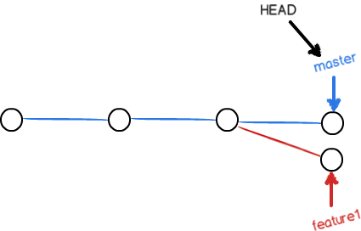

这种情况下，Git无法执行“快速合并”，只能试图把各自的修改合并起来，但这种合并就可能会有冲突，我们试试看：

$ git merge feature1

Auto-merging readme.txt

CONFLICT (content): Merge conflict **in** readme.txt

Automatic merge failed; fix conflicts **and** **then** commit the result.

果然冲突了！Git告诉我们，readme.txt文件存在冲突，必须手动解决冲突后再提交。git status也可以告诉我们冲突的文件：

$ git status

On branch master

Your branch is ahead of 'origin/master' by 2 commits.

(**use** "git push" to publish your local commits)

You have unmerged paths.

(fix conflicts **and** run "git commit")

(**use** "git merge --abort" to abort the merge)

Unmerged paths:

(**use** "git add <file>..." to mark resolution)

both modified: readme.txt

no changes added to commit (**use** "git add" **and**/**or** "git commit -a")

我们可以直接查看readme.txt的内容：

Git is a distributed version control system.

Git is free software distributed under the GPL.

Git has a mutable index called stage.

Git tracks changes of files.<<<<<<< HEADCreating a new branch is quick & simple.

=======Creating a new branch is quick AND simple.

>>>>>>> feature1

Git用<<<<<<<，=======，>>>>>>>标记出不同分支的内容，我们修改如下后保存：

Creating a **new** branch is quick **and** simple.

再提交：

$ git add readme.txt $ git commit -m "conflict fixed"

[master cf810e4] conflict fixed

现在，master分支和feature1分支变成了下图所示：

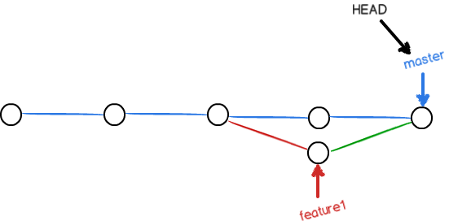

用带参数的git log也可以看到分支的合并情况：